Lab Submission: 2

Student Name: Michael Daly

Course and Section: CST8215 – 362

========================================================================

Lab 2 – Creating, populate and analyze database objects and content

In this Lab, we will use the script – WORLD-PG script. Please ensure you have downloaded it to your laptop prior to beginning.

Grading: Lab 2 is worth 6 marks

========================================================================

**Creating and populating the WORLD database**

Using the PGAdmin Query Tool, copy and paste the content of WORLD-PG into the query window and execute (lightning bolt). Look at the message section of the screen at the bottom to ensure the script ran without errors

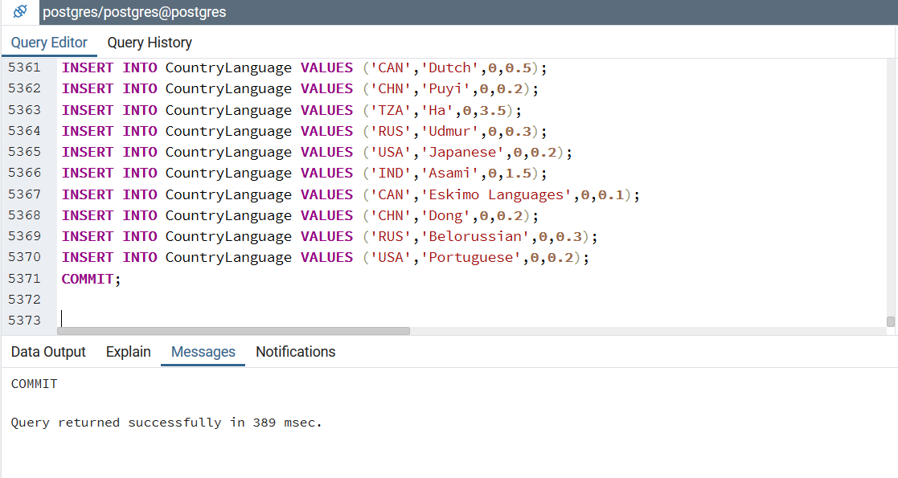

**Understanding SQL statements (DDL and DML) (3 marks - .5 each)**

What does DDL stand for?

*Data Definition Language*

Provide three examples of a DDL command?

*CREATE <table>*

*CONTRAINT <label>*

*PRIMARY KEY <attribute>*

Cut and paste one DDL statement from the WORLD-PG script and paste below

*CREATE TABLE City (*

*ID SERIAL PRIMARY KEY,*

*Name TEXT NOT NULL DEFAULT '',*

*CountryCode TEXT NOT NULL DEFAULT '',*

*District TEXT NOT NULL DEFAULT '',*

*Population INTEGER NOT NULL DEFAULT '0'*

*);*

What does DML stand for?

*Data Manipulation Language*

Provide three examples of a DML command?

*INSERT, UPDATE, SELECT*

Cut and paste one DML statement from the WORLD-PG script and paste below

*INSERT INTO City VALUES (1,'Kabul','AFG','Kabol',1780000);*

**Analyzing the data (database content) (3 marks - .5 each)**

Display the number of rows in the COUNTRY table where the column – *name* ends with the letter ‘m’

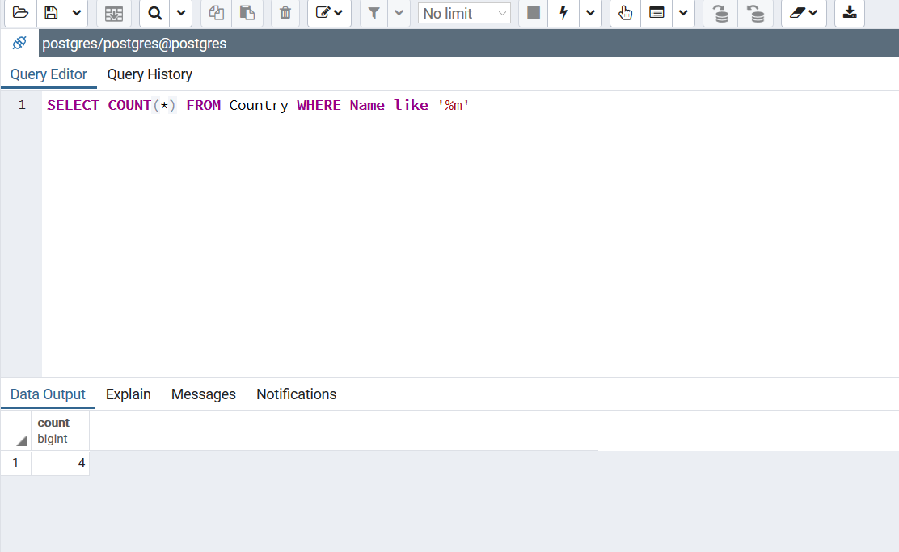

Display the columns, ***code*, *name*** and ***continent* from the COUNTRY table,**where *name* is sorted alphabetically

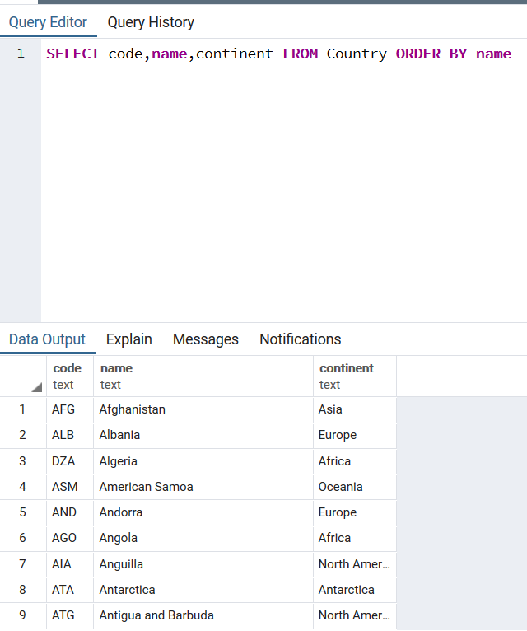

Display the columns ***name*** and ***surface area*** from the COUNTRY table. Sort the output so that rows displayed shows the country with largest *surface area* first and the country with the smallest *surface area* is displayed last.

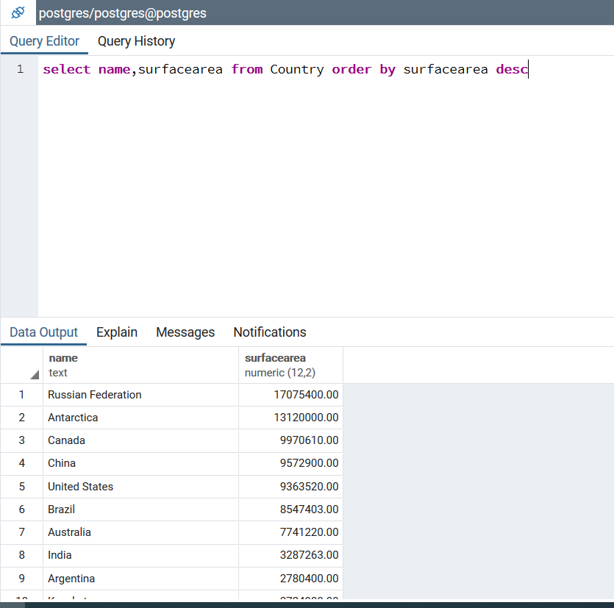

Display country that has the highest *life expectancy*

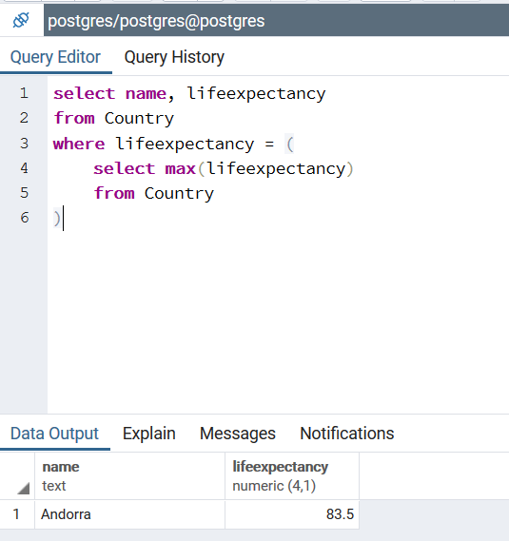

Display the average *life expectancy* of the countries listed in the COUNTRY table

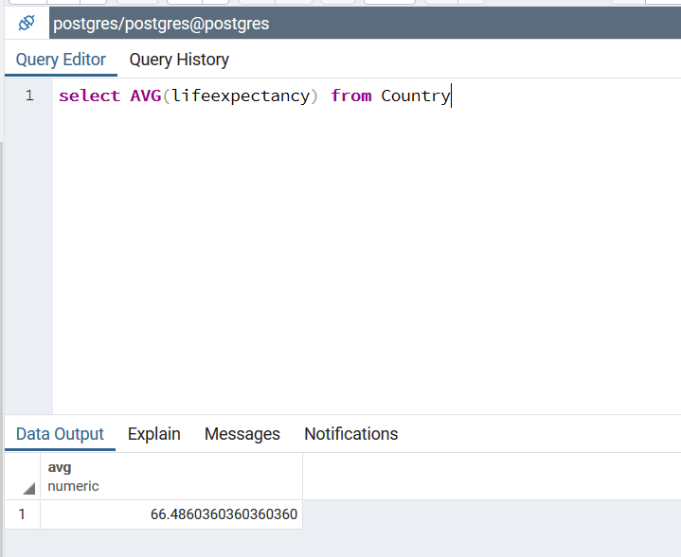

Display the count of only Canadian cities in the COUNTRY table

